Richmond, Peter (based on CALM News 1986)
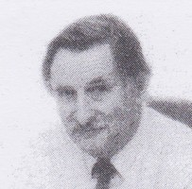
Lived in Tanyanyika. Earned Diploma in Forestry in UK. Joined Forests Department 16.12.1963 at Nannup. In 1971 transferred to Kalgoorlie, where he was involved with Sandalwood and extension. Moved to Perth 1980, as advisory officer, with responsibilities for Goldfields and Pilbara Regions, Sandalwood and private forestry. Retired 1986.

